Web-based CLIP Recommendations

Requirements:
- Web based application
- Common password for each site to allow multiple clinicians at each site to access application and get CLIP recommendations
- Ability to record all entries and instructions given.
- Accessible by blackberry, smart phones, etc. via web.
- All Checklist Elements are bulleted by checkboxes

Questions to be answered by clinician:
- Day of Hospitalization (Hospital admission day is Day 1 of Hospitalization): _________________ Hospital admission time : _________________
- Does the patient have a suspected infection?  Yes  No
If YES, is there a potentially removable or drainable source (such as abscess, line, hardware/implant, renal or gallstones, empyema, perforated viscus, acute abdomen, etc.)?
 Yes  No
- Is the patient currently in shock?  Yes  No
If NO, has patient been free of shock for 12 hours?  Yes  No
- Does the patient currently have acute bleeding?  Yes  No
- Does the patient currently have acute ischemia (acute coronary syndrome, acute stroke, acute bowel ischemia, or acute bowel ischemia)?  Yes  No
- Current respiratory status (Check one only):
  - Currently on non-invasive ventilation
  - Spontaneously breathing and NOT on invasive or non-invasive ventilation
  - Currently intubated/trached on mechanical ventilation
- Is admission/transfer to intensive care unit likely in the next 24 hours?
 Yes  No  Already in the ICU
- Will patient possibly need surgery in the next 24 - 48 hours?
 Yes  No

Shock
Infection
NO
YES
Removable source?
NO
YES
On vent
Respiratory status
On non-invasive vent
Not vented
Stop
Infection Control:
Antibiotics
Rapid administration of appropriate antibiotics (Table 1)

YES
NO
Infection Control:
Antibiotics:
Early administration of appropriate antibiotics within 6 hours (Table 1)
Source Control:
Early imaging to confirm source if appropriate
Early surgical /interventional evaluation if appropriate
Early drainage of purulent collection or removal of infected device if relevant
Bleeding or Ischemia?
NO
YES
Shock anytime in last 12 hrs?
YES
NO
Stop
Fluids and Transfusion:
Resuscitate and transfuse with blood and fluids as needed

Fluids and Transfusion:
Avoid fluid overload targeting CVP and urine output as per Fluid Management Goals below (Table 2)
RBC transfusion should be avoid unless Hb < 7 g/dL
Plasma and platelet transfusion should be avoided prior to minimally invasive procedures unless there is active bleeding

Fluids and Transfusion:
Resuscitate as needed

Bleeding
or
Ischemia?
YES
NO
Fluids and Transfusion:
Avoid fluid overload targeting CVP and urine output as per Fluid Management Goals below (Table 2)
Transfuse as needed

Respiratory Support:
Minimize ventilator induced lung injury
Low pressure ventilation with 6-8 cc/kg IBW (Table 3) and plateau pressures < 25 cm H₂O
Increase respiratory rate as needed to maintain ventilation (up to 35 bpm)
PEEP of at least 5 cm H₂O
Aspiration Precautions:
Elevate head of bed > 30º
Oral care with chorhexidine
Gastric acid neutralization
Respiratory Support:
Reassess work of breathing 30 mins into non-invasive ventilation and consider early intubation for: 1) severe hypoxemia (PF < 150), 2) lack of improvement in RR, use of accessory muscle, pH, pCO2 or mental status
If intubation needed:
Aspiration Precautions:
Consider rapid sequence intubation by experienced clinicians
Administer IV H2 antagonist to neutralize gastric acid
Minimize ventilator induced lung injury
Low pressure ventilation with 6-8 cc/kg IBW (Table 3) and plateau pressures < 25 cm H₂O
Increase respiratory rate as needed to maintain ventilation (up to 35 bpm)
PEEP of at least 5 cm H₂O

Respiratory Support:
Consider emergent rapid sequence intubation for shock

Shock?
YES
NO
If intubation needed:
Aspiration Precautions:
Consider rapid sequence intubation by experienced clinicians
Administer IV H2 antagonist to neutralize gastric acid
Minimize ventilator induced lung injury
Low pressure ventilation with 6-8 cc/kg IBW (Table 3) and plateau pressures < 25 cm H₂O
Increase respiratory rate as needed to maintain ventilation (up to 35 bpm)
PEEP of at least 5 cm H₂O
Minimize FiO₂ to target SpO₂ 93-98%
Shock?
NO
Stop
YES
ICU likely
NO
YES
Possible Surgery
YES
Stop
Communication:
Contact ICU fellow or attending with structured handoff (Table 4)

Already in ICU
Stop
Stop
Communication:
Contact surgical and anesthesia resident with structured handoff (Table 4)

NO
Table 1: Empiric Antibiotics
Presumed source | Suggested empiric antibiotics | If previous health care contact | If immune suppressed
Lung | ( Vancomycin / macrolide / 3rd gen cephalosporin )  OR  ( Vancomycin / fluoroquinolone )  *Consider treatment for influenza | ( Vancomycin / anti-pseudomonal PCN)  OR  ( Vancomycin / fluoroquinolone / Aminoglycoside )  *Consider treatment for influenza | ( Vancomycin / anti-pseudomonal PCN / macrolide )  *Consider treatment for PCP, fungals, Tb  *Consider treatment for influenza
Abdomen | ( Vancomycin / amino-PCN )  OR  ( Vancomycin / fluoroquinolone / metronidazole)  *Consider broader C.Diff coverage with PO vancomycin | ( Vancomycin / anti-pseudomonal PCN )  OR  ( Vancomycin / fluoroquinolone / metronidazole )  *Consider broader C.Diff coverage with PO vancomycin | ( Vancomycin / anti-pseudomonal PCN )  OR  ( Vancomycin / fluoroquinolone / metronidazole / aminoglycoside )  *Consider treatment for fungals, Tb  *Consider broader C.Diff coverage with PO vancomycin
Urine | ( 3rd generation cephalosporin )  OR  ( fluoroquinolone ) | ( Vancomycin / anti-pseudomonal PCN )  OR  ( Vancomycin / fluoroquinolone ) | ( Vancomycin / anti-pseudomonal PCN )  OR  ( Vancomycin / fluoroquinolone / Aminoglycoside )  *Consider treatment for fungals, Tb
CNS | ( Vancomycin / ceftriaxone )  *Consider treatment for viral  *Consider ampicillin for Listeria | ( Vancomycin / cefepime )  *Consider treatment for viral  *Consider ampicillin for Listeria | ( Vancomycin / cefepime / acyclovir / ampicillin )  *Consider treatment for fungals, Tb
IV Catheter | N/A | ( Vancomycin / anti-pseudomonal PCN ) | ( Vancomycin / anti-pseudomonal PCN )
Skin / Tissue | ( Vancomycin )  *Consider anti-pseudomonal PCN if diabetic or vascular disease  *Consider clindamycin for suspected toxic shock syndrome | ( Vancomycin / anti-pseudomonal PCN )  *Consider clindamycin for suspected toxic shock syndrome | ( Vancomycin / anti-pseudomonal PCN )  *Consider clindamycin for suspected toxic shock syndrome
Unknown | ( Vancomycin / anti-pseudomonal PCN ) | ( Vancomycin / anti-pseudomonal PCN ) | ( Vanco / carbapenem / fluoroquinolone )

Table 2: Fluid Management Goals
Estimated CVP | MAP > 60 mm Hg AND off vasopressors for > 12 hours
Estimated CVP | Average urine output < 0.5 ml/kg/hr | Average urine output > 0.5 ml/kg/hr
>8 | Furosemide*  Reassess in 1 hour | Furosemide*  Reassess in 4 hours
4-8 | Give fluid bolus as fast as possible  Reassess in 1 hour | Furosemide*  Reassess in 4 hours
< 4 | Give fluid bolus as fast as possible  Reassess in 1 hour | No intervention  Reassess in 4 hours

Table 3: Tidal volume settings according to height and gender
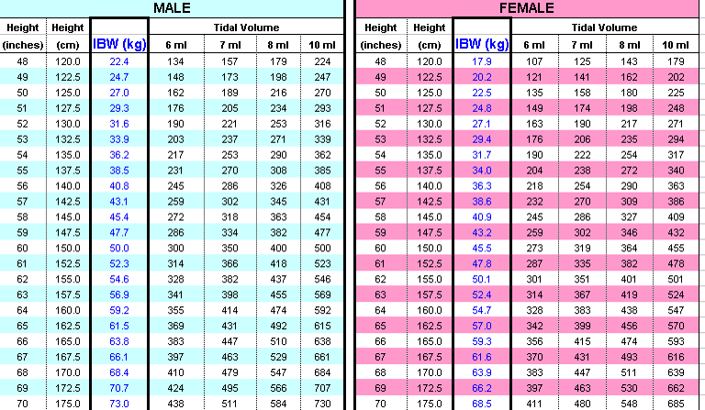

Table 4: SBAR : Structured communication during patient transfer to ICU or OR
SITUATION
- Introduce yourself and the patient
- Briefly describe the patient’s situation and reason for ICU transfer or surgery
BACKGROUND
- Briefly state the pertinent history
- What got us to this point
ASSESSMENT
- Identify patient as high risk for ALI/ARDS
- Indicate CLIP elements to be implemented and continued
- What is going on? Use your best judgment.
- What intervention/treatment did you start and how did the patient respond?
- What is patient’s current state?
- Is the patient improving, deteriorating, not changed?
RECOMMENDATION / REQUEST
- Indicate CLIP elements to be implemented and continued for duration of ICU stay or during OR
- What laboratory or radiologic tests are pending that will require follow up?
- Who have been consulted and what recommendations have to be followed up?
- What therapies need to be continued or followed up?

